Chef Raphaël Gamon
TCMchef | raphael@tcmchef.com | 424-288-6819 | tcmchef.com

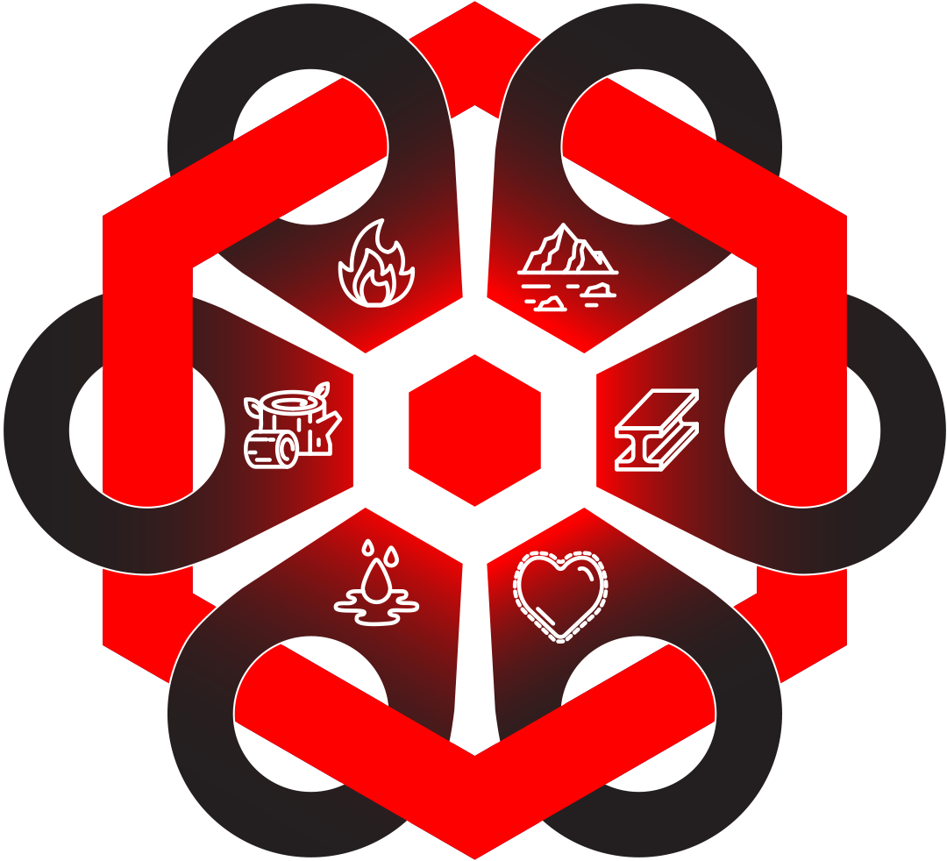

Biography
Chef Raphaël Gamon was raised in a Buddhist farm-household where nature, balance, and the five elements were not philosophy but daily practice. That foundation never left him. It shaped the way he cooks, the way he thinks about food, and the way he approaches every client who sits at his table.
Trained at a Swiss culinary academy and deepened by years in southern France, his view of cuisine as a bridge between culture, health, and human vitality was crystallized by a defining encounter with French cultural minister Jacques Lang at the Palais Royal. From that moment, food and meaning became inseparable in his practice.
Over 35 years, Chef Raphaël has served royalty, heads of state, and high-net-worth clients across four continents, earning a reputation built on discretion, precision, and results. He is the only private chef in the world to have trained with Eu Yan Sang International, Asia's foremost Traditional Chinese Medicine institution, a distinction that led directly to the launch of the world's first TCM-French fusion restaurant in Singapore. That pioneering concept proved what he had long believed: that medicinal principles and classical culinary artistry are not in conflict. They are, in fact, a natural alliance.
His published book, Cooking with Traditional Medicine, is not a recipe collection. It is a personalized health journal and self-study tool, 246 pages of science-grounded medicinal food knowledge with interactive sections throughout that invite each reader to document their own health journey, conditions, and goals. By the final chapter, a reader managing IBS, inflammation, mental imbalance or cancer support has developed a food protocol that is entirely their own. It is, in Chef Raphaël's own words, a book that should be in every household. Available now on Amazon.
Chef Raphaël is based in Los Angeles and available for private engagements, group cooking classes, speaking events, and media appearances worldwide.

